EXPERIMENT NO. 27

Committing and Pushing Changes to a GitHub Repository

Aim
To modify a file in a cloned GitHub repository, commit the changes locally, and push the updated files to GitHub.

Software Requirements
- Windows 10/11 (or Linux/macOS)
- Git
- GitHub Account
- Visual Studio Code (or any code editor)
- Web Browser
- Internet Connection

Theory
Git allows developers to track changes made to project files. After modifying a file, the changes are staged using git add, committed using git commit, and uploaded to the remote GitHub repository using git push. This keeps the local and remote repositories synchronized.

Procedure
Step 1: Clone the Repository
Open Git Bash or Terminal.
git clone https://github.com/YourUsername/RepositoryName.git

Move to the project folder.
cd RepositoryName

Step 2: Open the Project
Open the repository in Visual Studio Code.
code .

Step 3: Modify a File
- Open the README.md file.
- Add or edit a few lines of text.
- Save the file.
Example:
# Sample Project
This project demonstrates Git commit and push operations.

Step 4: Check the Repository Status
git status

Verify that the modified file is listed.
Step 5: Stage the Changes
git add README.md

To stage all modified files, use:
git add .

Step 6: Commit the Changes
git commit -m "Updated README"

Step 7: Push the Changes to GitHub
git push origin main

If your default branch is master, replace main with master.
Step 8: Verify the Changes
- Open the repository on GitHub.
- Refresh the page.
- Confirm that the updated README.md file is visible.

Screenshots
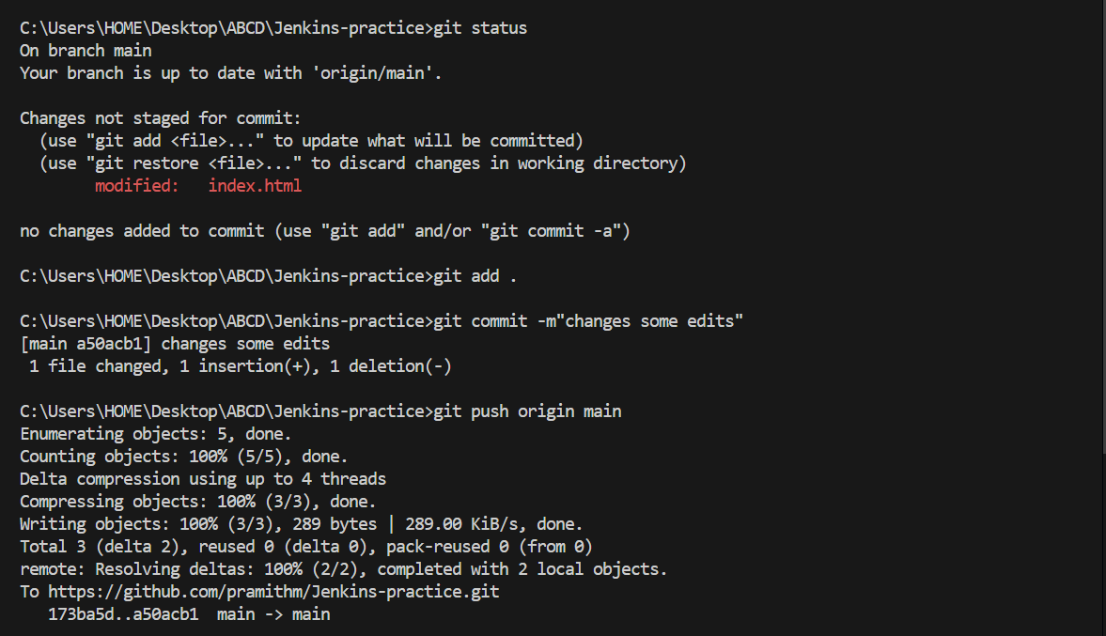

Observation
- The repository was cloned successfully.
- The README.md file was modified.
- Changes were staged successfully.
- The changes were committed with a commit message.
- The commit was pushed successfully to GitHub.
- The updated file was visible in the remote repository.

Result
The file in the cloned GitHub repository was successfully modified, staged, committed, and pushed to GitHub. The remote repository was updated with the latest changes.

